To create persuasive writing which convinces the reader to think or act in a particular way, you might want to:
Year 1 & Year 2 | Year 3 & Year 4 | Year 5 & Year 6
- The structure should comprise:  - A catchy title naming the product or event e.g. The Red Class Crispy Biscuit  - An opening sentence or two inviting readers to e.g. Try the Red Class Crispy biscuit.  - A series of positive points to recommend the event or product e.g. You will really like our biscuits because: They are really crispy and delicious…, they are perfect for a quick snack…, they don’t leave any crumbs…, they contain nuts which are good for you…, they are very cheap at 5 pence each…, all the money we collect is for helping sick animals…  - A conclusion drawn from the points e.g. you are sure to enjoy these great biscuits, so come to our class and buy some today.  - Focus on a few essential conjunctions to join ideas and structure the argument:  - numerical firstly, secondly…, to list points  - conjunctions and, but, because, as, when to add information and extend ideas  - if…then…, to persuade e.g. If you enjoy biscuits, you will really enjoy...  - Bank and use adjectives which enhance persuasive impact: delicious, crispy, fascinating, gripping, unmissable etc.  - Use simple comparatives and superlatives: best, fastest, lighter, tastier etc.  - Use the present tense and usually 2nd person/ directive language (you) to talk directly to the reader | - Consolidate and extend the text structure introduced in Y1/2 with:  - a title to hook reader and capture the topic clearly e.g. The Mary Rose – an unmissable experience  - an introduction which: (a) Invites the reader directly e.g. Have you ever wondered…?, If you enjoy… don’t miss…, What could be easier than to…? (b) uses a punchy topic sentence to make clear what is being promoted e.g. The New Mary Rose exhibition could be just the place to visit this weekend…,  - a main section setting out the points in favour in a connected sequence: (a) as a list with numbers, numerical conjunctions or bullets. (b) as a connected paragraph, or series of paragraphs.  - Introduce points with a topic sentence e.g. The sky tower gives you…, or an invitation e.g. See things differently from the top of the sky tower… Add information to tempt and entice e.g. In the old mill, where they still grind flour…  - a conclusion to round off e.g. At the end of your visit why not enjoy…, you can have all this and more for the price of…, Book now. Tickets are available from…,  - Bank and use a variety of persuasive devices:  - use of informal language: Join us for a great day out…  - imperative, direct forms of address: Don’t forget to ride on the train…  - Repetition: Find us, find the fun…,  - boasting and exaggeration: The highest tower in the south of England…, The Uk’s first…, breathtaking.., stunning…, hair-raising…, fantastic…, fabulous…, incredible…,  - Short sentences: Don’t wait…try it now…,  - Patterns of three: Make your own T-shirt in 15 minutes: design it, print it, wear it…,  - Use complex sentences to combine and compress information, create emphasis and make the text more interesting for the reader:  - relative clauses e.g. This walkway, which has the one of the longest….,  - subordinate clauses: On the train ride, as you cross the bridge, a red signal will…  - Use a wider range of conjunctions and connecting phrases to:  - Address and invite readers: See the new…, Have you ever been… etc.  - add information: as well as…, additionally…, etc.  - mark time and sequence: when, after, as soon as…, etc.  - change of direction: but, however, although, etc. | - When assembling arguments:  - try to support views with reasons or evidence e.g. …According to the Daily Mail, more than 10,000 homes could face demolition if a proposed third runway is built at Heathrow.  - offer and refute some counter arguments e.g. Now some people might object that…,  - disguise opinions to sound like facts e.g. In fact…, The truth is…, in what some would call the most important moment in..., It has frequently been claimed that…  - or (more rationally) make clear that these are your opinions e.g. I think.., in my opinion…,  - try to persuade using persuasive devices (see below),  - try to get the reader interested and on your side - appear reasonable.  - Make your reader think that the rest of the world, agrees with you e.g. Everyone agrees that…, We all know that…  - Use humour as it can get people on your side.  - Express possibility, speculation and conditionality, using modal verbs may, might, should, could, would etc. and adverbs perhaps, surely, possibly; phrases like provided that…, so long as… etc.  Vary sentence structure, length and type e.g.  - complex sentences to combine and compress information: Although a decision is yet to be taken, there is already evidence showing that a new runway could damage the health of local residents, and might could even prove fatal for babies…  - Short sentences for effect e.g. No-one wants this.  - Sentence openers: interestingly…, from our point of view…, Indeed there could even be…, Passive voice to sound more formal: It could be said that…, Additional disturbance would be created by…  - Conditional and hypothetical (if…then) sentences using the subjunctive ‘were’ If that’s the best they can offer…, If it were to be approved…,  Examples of persuasive devices
Draw on persuasive devices from Y3/4 plus others e.g.:
- extreme adjectives and superlatives e.g. ghastly, appalling, fantastic, the coolest, hideous, fabulous…,
- Exaggeration e.g. …the biggest single change to our town for fifty years…, …vast numbers of people…, the last place on earth…, great opportunity…,
- emotive language e.g. No-one would believe that the…, Just imagine the effect that…, … sprawling across the field…,
- language that claims authority disguising opinions to sound like facts e.g. In fact…, It is said that…, there can be no doubt that…,
- Rhetorical questions e.g. Should we all be expected to…? Who would believe that…?
- alliteration e.g. … mean-minded men…, silly and shortsighted…, cheap and cheerful…, funky, friendly and fantastic…, Buy British…
- persuasive language e.g. Surely…, It wouldn’t be difficult to…, is bound to be…, there can be little doubt…
- Persuasive definitions e.g. No-one but an idiot would…, Every right-thinking person would…,
- Pandering and condescension: Naturally it will take time for people to realise…, the ordinary man in the street…,
- similes and metaphors e.g. … like a desert at night…, like shopping in a factory; …the whole idea is a joke!.... …the hedgerow is a treasure trove for birds, …and more cars would be a nightmare…, but parking bikes in narrow spaces is a piece of cake.
- Sarcasm, used sparingly, e.g. the government is likely to support that…, (implying the opposite).
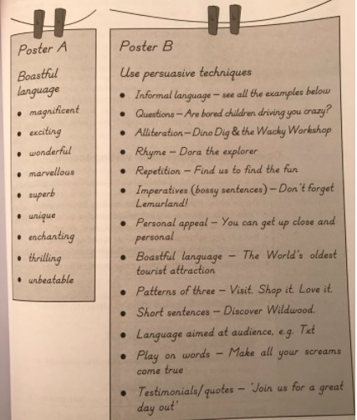
Typical ingredients of instructions text:
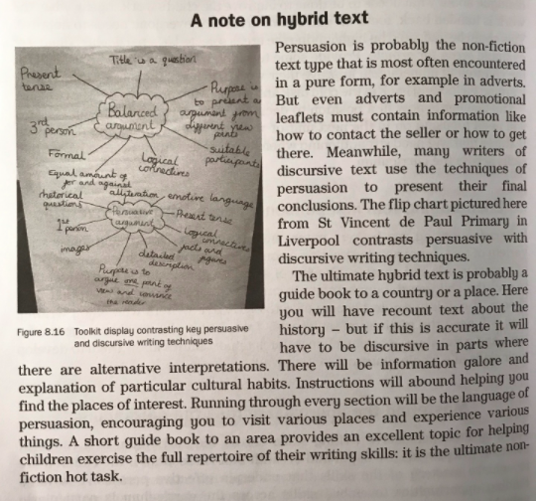
Audience | - Someone you are trying to influence
Purpose | - To promote a particular view or product in order to influence what people think or do
Typical Structure | - Logical order  - A series of points building one viewpoint  - Paragraphs with topic sentence in introduction (and in all paragraphs for longer text)  - Often includes images to attract attention
Typical Language Features | - Personal and direct, often informal (friendly)  - Emotive sentence signposts  - Opinions presented as facts  - Use of the imperative  - Use of language that sounds good, including slogans  - Weasel words (emotive language designed to deceive/give best impression)
Examples | - Adverts  - Newspaper editorials  - Promotional leaflets  - Pamphlets promoting a particular viewpoint  - Persuasive Letters

