To create information writing which informs the reader in an interesting way, you might want to:
EYFS | Year 1 & Year 2 | Year 3 & Year 4 | Year 5 & Year 6
Use shared writing to create a simple text e.g.:  - A title and simple introductory topic sentence: Tractors are very big, they plough fields and pull heavy loads…,  - list points, re-read, extend as discussion develops: Tractors have enormous wheels to drive over rough ground; Some tractors have a cab to keep the driver dry in the rain; They cannot go very fast, Sometimes they are used to…etc.  - a conclusion with a more personal touch: We have a toy tractor in our play area with two trailers | - Learn and retell simple information texts with a three-part structure in sentences or short paragraphs:  - an opening that introduces reader to the topic e.g. Dinosaurs are large reptiles which lived millions of years ago.  - a number of chunks of information about the topic e.g. Some dinosaurs ate meat. These are carnivores.…, Dinosaurs are extinct, which means they are not alive today …., The T-Rex was a large dinosaur. Its name meant king of the tyrant lizards…  - a conclusion with an amazing fact e.g. Although dinosaurs are extinct, birds we see today have evolved from dinosaurs. So there could in fact be an ancestor of a dinosaur in your garden!  - Use conjunctions to link and add information: and, also, as well as etc.  - Use well-chosen adjectives to denote size, colour, behaviour etc.: T-Rex was a large, ferocious and powerful dinosaur…  - Use prepositions where appropriate to show position and direction: behind, above, towards etc.  - Use correct sentence punctuation and, for an amazing fact, an exclamation mark!  - Write in the present tense and usually 3rd person to give text an impersonal and objective voice. | - Collect and organise ideas developing the three part structure (Y1/2) ‘boxing-up’ information to plan the writing sequence with:  - a topic sentence to capture interest and define subject.  - A reason and/or invitation to read on;  - more detailed definitions e.g. of type, appearance, where found, habitat and diet for creatures, purposes and uses for materials etc.;  - a range of interesting facts and ideas about the topic in a sequence which builds up information logically;  - a conclusion leaving an amazing, unexpected and memorable fact to leave the reader thinking.  - Use a more sophisticated range of generalisers and signposts/conjunctions:  - generalisers e.g. all…, many…, the majority…, typically…, Like most…, always…, often…, sometimes.., usually…  - to add information: as well as…, furthermore…, additionally…, moreover…, Not only…,  - showing cause and effect: because.., so…, as a result…, due to…, this means that…,  - to compare: like the…, similarly.., as with…, equally…, in contrast to.., etc.  - for emphasis: most of all…, most importantly…, In fact…, without doubt.., etc.  - Use correct punctuation: commas to mark clauses in sentences, commas for lists, colons and bullets for lists where appropriate  - Use mostly present tense, 3rd person in formal style for an unknown audience.  - Collect and use specialised and technical vocabulary linked to the topic: originated, mammal, rainforest; roman, gladiator etc.  - Use complex sentences to combine information clearly and precisely, and vary sentence style and length to keep the reader interested e.g. Dormice are small, nocturnal rodents who can hibernate for up to 6 months each year, while the weather is cold | - Consolidate and extend use of information text structure from Y3/4 to include:  - An expanding range of conjunctions and generalisers:  - Use of provisional statements with words and phrases like usually…, seem to be…, tend to…,  - Add in opinions as well as facts e.g. Some people still believe that… It used to be thought that…  - Use technical vocabulary to add precision e.g. spine, compression, glucose  - Add in references to sources of evidence to add authority e.g. Most people now believe…, However, last year, a new variety was discovered…  - Write reports for different audiences and purposes  - to interest or attract: language e.g. The best thing about Stroud on a Saturday morning is the Farmers’ Market…Local farmers and gardeners sell honey, home-made cheeses… etc.  - to warn: Some people think that mushrooms are edible and toadstools are poisonous. In fact there is no difference between them, which can get mushroom hunters into a lot of trouble.  - to report objectively: e.g. The bicycle, usually called a bike, is a human-powered vehicle with two wheels attached to a frame. Bicycles were introduced in the 19th century in Europe…  - Vary sentence structure, length and type e.g.  - complex sentences to combine information clearly and precisely, and vary sentence style and length to keep the reader interested e.g. Dormice are very small, nocturnal rodents who can hibernate for up to 6 months each year, while the weather is cold.  - sentences with lists of three: Dormice are fast, agile and extremely well adapted to climbing.  - active and passive voices: Baby dormice are born helpless and hairless (active). They need to be looked after by their mothers for the first 20 days…, (passive)  - conditional and hypothetical (if…then) sentences e.g.: If they are woken up too soon…,  - exclamatory sentences: To this day, dormice are hunted and eaten in Slovenia!  - Collect interesting nuggets of information to conclude texts and sustain the reader’s interest

Typical ingredients of instructions text:
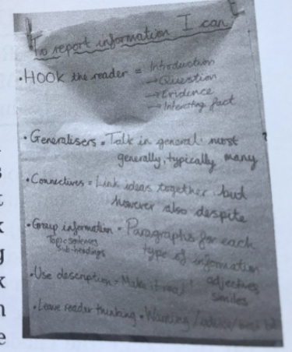
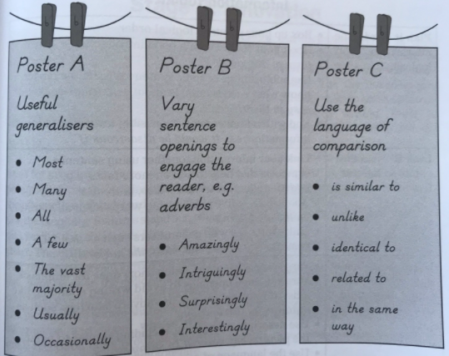
Audience | - Someone who is interested in the topic.  - Someone who enjoys information.
Purpose | - To inform the reader about the topic, describing its characteristics in an engaging and interesting way.
Typical Structure | - Opening that introduces the reader to the subject.  - Chunks of information, logically organized, possibly with subheadings, information boxes, lists, bullet points, diagrams and images.  - Paragraphs usually begin with a topic sentences.  - Ending – that makes a final ‘amazing’ point or relates the subject to the reader.
Typical Language Features | - Generalisers such as – most, many, some, a few, the majority.  - Sentence signposts to add information – furthermore, also, moreover, additionally.  - Subject-specific and technical vocabulary.  - Often in the present tense and third person, e.g. whales are large.  - Usually fairly formal, especially if written for an unknown reader.  - Detail and description, including comparisons.
Examples | - Natural world: sharks, dinosaurs, butterflies, flowers, etc.  - Places: our school, India, River Nile, etc.  - People: Life in the Caribbean, Living in a desert, etc.  - Objects: Racing cars, mobile phones etc.  - Hobbies: Football, Dance etc.

